**First Synopsis**

**On**

**<project name>**

***Submitted To***: ***Submitted By:***

<Project Incharge Name> <Your Name (Roll No)>

<HOD Name>

**Department of <your department in college>**

**<College Name>**

**ACKNOWLEDGEMENT**

I am highly grateful to [Teacher In charge], for providing assistance for the two months industrial training.

I want to express gratitude to [HOD NAME] of Department of Computer science and Technology for their intellectual support throughout the training Course.

I want to thank [Principal & Director’s Name] from the core of my heart to provide all the infrastructure throughout the course.

<Your Name>

**TABLE OF CONTENTS**

|  |  |  |
| --- | --- | --- |
| **Sr. No.** | **Topic** | **Page No.** |
| 1. | Introduction to Project |  |
| 2. | Front End |  |
| 3. | Back End |  |
| 4. | Hardware and Software Requirements |  |
| 5. | Tools used for development |  |
| 6. | Bibliography |  |

**INTRODUCTION:**

<insert your first synopsis here. **Introduction and Features**>

<Use Times New Roman font throughout the file (front page is an exception)>

<Headings: 14pt. , Bold e.g. Introduction, Software Model followed etc.>

<Sub Headings: 12 pt., Bold e.g. Features, Hardware Requirements etc.>

<Body: 12 pt. >

**INTRODUCTION TO PHP**



PHP is a powerful language and the interpreter, whether included in a web server as a module or executed as a separate CGI binary, is able to access files, execute commands and open network connections on the server.

These properties make anything run on a web server insecure by default. PHP is designed specifically to be a more secure language for writing CGI programs than Perl or C, and with correct selection of compile-time and runtime configuration options, and proper coding practices, it can give you exactly the combination of freedom and security you need.

As there are many different ways of utilizing PHP, there are many configuration options controlling its behaviour. A large selection of options guarantees you can use PHP for a lot of purposes, but it also means there are combinations of these options and server configurations that result in an insecure setup.

The configuration flexibility of PHP is equally rivalled by the code flexibility. PHP can be used to build complete server applications, with all the power of a shell user, or it can be used for simple server-side includes with little risk in a tightly controlled environment. How you build that environment, and how secure it is, is largely up to the PHP developer.

**MARKET SHARE OF PHP**

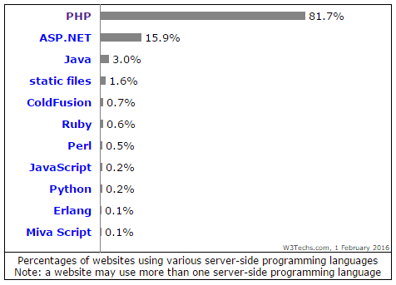

**HISTORY**

PHP development began in 1995 when RasmusLerdorf wrote several Common Gateway Interface (CGI) programs in C, which he used to maintain his personal homepage He extended them to work with web forms and to communicate with databases, and called this implementation "Personal Home Page/Forms Interpreter" or PHP/FI.

PHP/FI could be used to build simple, dynamic web applications. To accelerate bug reporting and improve the code, Lerdorf initially announced the release of PHP/FI as "Personal Home Page Tools (PHP Tools) version 1.0" on the Usenet discussion group *comp.infosystems.www.authoring.cgi* on June 8, 1995 This release already had the basic functionality that PHP has as of 2013. This included Perl-like variables, form handling, and the ability to embed HTML. The syntax resembled that of Perl but was simpler, more limited and less consistent.

Early PHP was not intended to be a new programming language, and grew organically, with Lerdorf noting in retrospect: "I don’t know how to stop it, there was never any intent to write a programming language […] I have absolutely no idea how to write a programming language, I just kept adding the next logical step on the way." A development team began to form and, after months of work and beta testing, officially released PHP/FI 2 in November 1997.

**Features**

* Open Source (Only one file encrypted) .
* Nice layout from start.
* Support Most payment vendors.
* Unlimited level of categories.
* Unique Extra Fields that is also sortable.
* Large user community.
* Uses Template and language system that keeps your customize.
* Regions Module is included (using Ajax).
* Picture Gallery.
* Publishing tool for custom pages by you.
* Easy code.
* Normalized Database Layout
* Fast.
* Image, Video and Document upload.

**Installation and configuration**

There are two primary ways for adding support for PHP to a web server – as a native web server module, or as a CGI executable. PHP has a direct module interface calledServer Application Programming Interface (SAPI), which is supported by many web servers including Apache HTTP Server, Microsoft IIS, Netscape (now defunct) and iPlanet. Some other web servers, such as OmniHTTPd, support the Internet Server Application Programming Interface (ISAPI), which is a Microsoft's web server module interface. If PHP has no module support for a web server, it can always be used as a Common Gateway Interface (CGI) or FastCGI processor; in that case, the web server is configured to use PHP's CGI executable to process all requests to PHP files.

PHP-FPM (FastCGI Process Manager) is an alternative FastCGI implementation for PHP, bundled with the official PHP distribution since version 5.3.3. When compared to the older FastCGI implementation, it contains some additional features, mostly useful for heavily loaded web servers.

When using PHP for command-line scripting, a PHP command-line interface (CLI) executable is needed. PHP supports a CLI SAPI as of PHP 4.3.0..

Usage

PHP is a general-purpose scripting language that is especially suited to server-side web development, in which case PHP generally runs on a web server. Any PHP code in a requested file is executed by the PHP runtime, usually to create dynamic web page content or dynamic images used on websites or elsewhere. It can also be used for command-line scripting and client-side graphical user interface (GUI) applications. PHP can be deployed on most web servers, many operating systems and platforms, and can be used with many relational database management systems (RDBMS). Most web hosting providers support PHP for use by their clients. It is available free of charge, and the PHP Group provides the complete source code for users to build, customize and extend for their own use.

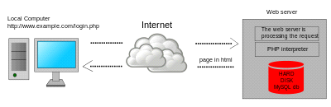

Dynamic web page: example of server-side scripting (PHP and MySQL).

PHP acts primarily as a filter, taking input from a file or stream containing text and/or PHP instructions and outputting another stream of data. Most commonly the output will be HTML, although it could be JSON, XMLor binary data such as image or audio formats. Since PHP 4, the PHP parser compiles input to producebytecode for processing by the Zend Engine, giving improved performance over its interpreterpredecessor.

**INTRODUCTION TO MY SQL**



MySQL is an open-source relational database management system (RDBMS). Its name is a combination of "My", the name of co-founder Michael Widenius' daughter, and "SQL", the abbreviation for Structured Query Language.

The MySQL development project has made its source code available under the terms of the GNU General Public License, as well as under a variety of proprietary agreements. MySQL was owned and sponsored by a single for-profit firm, the Swedish company MySQL AB, now owned by Oracle Corporation.

MySQL is a central component of the LAMP open-source web application software stack (and other "AMP" stacks). LAMP is an acronym for "Linux, Apache, MySQL, Perl/PHP/Python". Applications that use the MySQL database include: TYPO3, MODx, Joomla, WordPress, phpBB, MyBB, and Drupal. MySQL is also used in many high-profile, large-scale websites, including Google (though not for searches), Facebook, Twitter, Flickr, and YouTube.

**History**

MySQL was created by a Swedish company, MySQL AB, founded by David Axmark, Allan Larsson and Michael "Monty" Widenius. Original development of MySQL by Widenius and Axmark began in 1994. The first version of MySQL appeared on 23 May 1995. It was initially created for personal usage from mSQL based on the low-level language ISAM, which the creators considered too slow and inflexible. They created a new SQL interface, while keeping the same API as mSQL. By keeping the API consistent with the mSQL system, many developers were able to use MySQL instead of the (proprietarily licensed) mSQL antecedent.

**Features**

MySQL is offered under two different editions: the open source MySQL Community Server and the proprietary Enterprise Server. MySQL Enterprise Server is differentiated by a series of proprietary extensions which install as server plugins, but otherwise shares the version numbering system and is built from the same code base.

Major features as available in MySQL 5.6:

* A broad subset of ANSI SQL 99, as well as extensions
* Cross-platform support
* Stored procedures, using a procedural language that closely adheres to SQL/PSM[62]
* Triggers
* Cursors
* Updatable views
* Online DDL when using the InnoDB Storage Engine.
* Information schema
* Partitioned tables with pruning of partitions in optimizer
* Shared-nothing clustering through MySQL Cluster
* Multiple storage engines, allowing one to choose the one that is most effective for each table in the application.
* Native storage engines InnoDB, MyISAM, Merge, Memory (heap), Federated, Archive, CSV, Blackhole, NDB Cluster.
* Commit grouping, gathering multiple transactions from multiple connections together to increase the number of commits per second.

**Deployment**

MySQL can be built and installed manually from source code, but it is more commonly installed from a binary package unless special customizations are required. On most Linux distributions, the package management system can download and install MySQL with minimal effort, though further configuration is often required to adjust security and optimization settings.

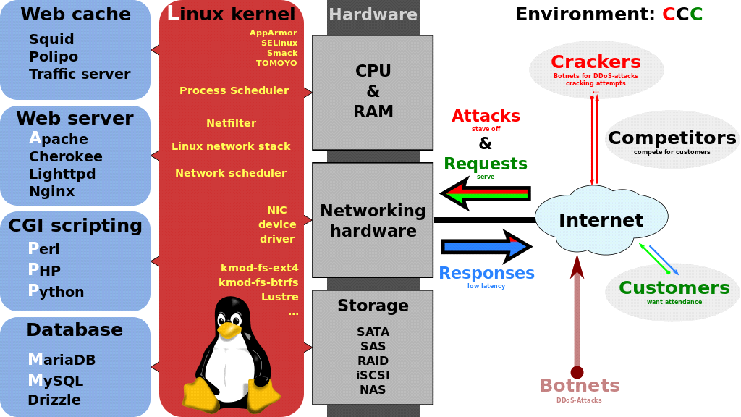

Though MySQL began as a low-end alternative to more powerful proprietary databases, it has gradually evolved to support higher-scale needs as well. It is still most commonly used in small to medium scale single-server deployments, either as a component in a LAMP-based web application or as a standalone database server. Much of MySQL's appeal originates in its relative simplicity and ease of use, which is enabled by an ecosystem of open source tools such as phpMyAdmin. In the medium range, MySQL can be scaled by deploying it on more powerful hardware, such as a multi-processor server with gigabytes of memory.

A typical high-end configuration can include a powerful master database which handles data write operations and is replicated to multiple slaves that handle all read operations. The master server continually pushes binlog events to connected slaves so in the event of failure a slave can be promoted to become the new master, minimizing downtime. Further improvements in performance can be achieved by caching the results from database queries in memory using memcached, or breaking down a database into smaller chunks called shards which can be spread across a number of distributed server clusters.

**HARDWARE & SOFTWARE REQUIREMENTS**

**Hardware requirements server**

1. Intel i3/i5/i7 processor

2. 2 GB Ram

3. 80 GB+ Hard disk space

4. Optical drive

5. Keyboard and mouse

6. Internet Connection

**Software requirements server**

1. Server based operating system

2. Apache HTTP Server 2.4.25

3. PHP 7.1x

4. Ajax Support

**Hardware requirements Client**

1. Any PC processor

2. 512 MB Ram

3. Keyboard mouse

4. Internet Connection

**Software Requirements Client**

* Any operating system
* Web Browser

**TOOLS TO BE USED FOR DEVELOPMENT**

For the Front End **JetBrainsPhpStorm**is being utilized as in IDE:-



**JetBrainsPhpStorm** is a commercial, cross-platform IDE for PHP built on JetBrains' IntelliJ IDEA platform.

PhpStorm provides an editor for PHP, HTML and JavaScript with on-the-fly code analysis, error prevention and automated refactoring for PHP and JavaScript code. PhpStorm's code completion supports PHP 5.3, 5.4, 5.5 & 5.6 (modern and legacy projects), including generators, coroutines, the finally keyword, list in foreach, namespaces, closures, traits and short array syntax. It includes a full-fledged SQL editor with editable query results.

PhpStorm is built on IntelliJ IDEA, which is written in Java. Users can extend the IDE by installing plugins created for the IntelliJ Platform or write their own plugins.

All features available in WebStorm are included in PhpStorm, which adds support for PHP and databases. WebStorm ships with pre-installed JavaScript plugins (such as for Node.js), which are available for PhpStorm as well at no cost.

**Features of JetBrains**

* **Deep insight into your code:** IntelliJ IDEA analyzes your code, looking for connections between symbols across all project files and languages. Using this information it provides indepth coding assistance, quick navigation, clever error analysis, and, of course, refactorings.
* **Smart completion:** Ctrl+Shift+Space gives you a list of the most relevant symbols applicable in the current context. This and other completions are constantly learning from you, moving the members of the most frequently used classes and packages to the top of the suggestions list, so you can select them faster.
* **Detecting duplicates:** Finds duplicate code fragments on the fly. Even if you're only about to extract a variable, constant, or a method, IntelliJ IDEA will let you know that there is a similar code fragment that can be replaced along with the one you're woking on.
* **Inspections and quick-fixes:** Whenever IntelliJ IDEA detects that you're about to make a mistake, a little lightbulb pops up in the editor. Clicking it or pressing Alt+Enter opens a list of actions you can take to make things right.
* **Shortcuts for everything:** In IntelliJ IDEA you have dedicated keyboard shortcuts for nearly everything, including rapid selection and switching between tool windows and the editor. Accessing a tool window via its shortcut moves the input focus to it, so you can use all keyboard commands in its context. When you need to go back to the editor, just hit Esc. When you're in the Project tool window, you can not only navigate through the existing items, but also create new ones by just pressing Alt+Ins.
* **Database tools:** Take advantage of intelligent coding assistance when editing SQL; connect to live databases; run queries; browse and expert data; and even manage your schemes in a visual interface–right from the IDE.
* **Version control:** IntelliJ IDEA provides a unified interface for major version control systems including Git, SVN, Mercurial, CVS, Perforce, and TFS. The IDE lets you browse the history of changes, manage branches, merge conflicts and much more
* **Decompiler:** IntelliJ IDEA comes with a built-in decompiler for Java classes. When you want to take a look inside a library that you don't have the source code for, now you can – without any third-party plugins.

**History**

JetBrains, initially called IntelliJ, was founded in 2000 in [Prague](https://en.wikipedia.org/wiki/Prague) by three software developers: Sergey Dmitriev, ValentinKipiatkov and Eugene Belyaev.

The company's first product was IntelliJRenamer, a tool for [code refactoring](https://en.wikipedia.org/wiki/Code_refactoring) in Java.

In 2012, after having been the company's CEO for 12 years, Sergey Dmitriev entrusted the company to two newly appointed CEOs, Oleg Stepanov and Maxim Shafirov, and devoted himself to his scientific endeavors in the field of [bioinformatics](https://en.wikipedia.org/wiki/Bioinformatics).

For the Back End **XAMPP** is being utilized for Database:-

**XAMPP** is a [free and open source](https://en.wikipedia.org/wiki/Free_software) [cross-platform](https://en.wikipedia.org/wiki/Cross-platform) [web server](https://en.wikipedia.org/wiki/Web_server) [solution stack](https://en.wikipedia.org/wiki/Solution_stack) package developed by Apache Friends, consisting mainly of the [Apache HTTP Server](https://en.wikipedia.org/wiki/Apache_HTTP_Server), [MariaDB](https://en.wikipedia.org/wiki/MariaDB) [database](https://en.wikipedia.org/wiki/Database), and [interpreters](https://en.wikipedia.org/wiki/Interpreter_(computing)) for scripts written in the [PHP](https://en.wikipedia.org/wiki/PHP) and [Perl](https://en.wikipedia.org/wiki/Perl) [programming languages](https://en.wikipedia.org/wiki/Programming_language). XAMPP stands for Cross-Platform (X), Apache (A), MariaDB (M), PHP (P) and Perl (P). It is a simple, lightweight Apache distribution that makes it extremely easy for developers to create a local web server for testing and deployment purposes. Everything needed to set up a web server – server application (Apache), database (MariaDB), and scripting language (PHP) – is included in an extractable file. XAMPP is also cross-platform, which means it works equally well on Linux, Mac and Windows. Since most actual web server deployments use the same components as XAMPP, it makes transitioning from a local test server to a live server extremely easy as well.

**Latest Version of xampp is 7.1.4**

**OS Requirement for the Xampp is:** Windows XP / Vista / Windows 7 / Windows 8 / Windows 10 / Windows XP64 / Vista64 / Windows 7 64 / Windows 8 64 / Windows 10 64

XAMPP is an easy to install Apache distribution for Windows, Mac OS X, Linux and Solaris. The package includes the Apache web server, MySQL, PHP, Perl, a FTP server and phpMyAdmin.

XAMPP has been designed to be the easiest way to install and run a development server. There are numerous other WAMP packages available, but XAMPP is one of the most complete on offer. In addition to Apache, MySQL, and PHP, XAMPP includes other really useful tools such as the phpMyAdmin database administration tool, FileZilla FTP server, Mercury mail server, Perl programming language, and JSP server Tomcat.

In the XAMPP control panel you can configure the above services with ease. XAMPP can also install an administration site as the home page of the server. From which you can undertake all manner of administrative tasks, such as checking the server status and security, launch tools like phpMyAdmin and Webalizer analytics. You can also view PHP demos which can be of use for those developers who are just starting out.

Overall, XAMPP is a great tool for anyone looking to get a full development server up and running within quick time constraints. The only issue that we can see, is that because it is so easy to setup, it doesn't have the security features for this to be used as a production server. However, if you really need to make the server Web accessible, then you can do so, albeit against the advice of the Apache Friends development team.

**BIBLIOGRAPHY:**

To bring the system to verge of completion the following books have been referred:

|  |  |
| --- | --- |
| **NAME OF THE BOOK** | **AUTHOR’S NAME** |
| Php: The Complete Reference | Steven Holzner |
| Head First PHP & MySQL | Lynn Beighley, Michael Morrison |

Some websites referred are:-

* <http://php.net/docs.php>
* [https://www.w3schools.com](https://www.w3schools.com/)
* <https://www.tutorialspoint.com/>